ME-GY 7943

Network Robotics Systems, Cooperative Control and Swarming

Kamal Patel

Exercise series 2

Exercise 1

**1)** **Prove that $q_{1}^{T} x(t)$ is a constant of motion. How can you interpret the result ?**

**Solution:**

To prove that $q_{1}^{T} x(t)$ is constant of motion

$$\frac{d}{dt} q_{1}^{T} x(t) = 0$$

$$q_{1}^{T} \dot{x(t)} = 0$$

we also know that $\dot{x\left(t\right)} = -Lx$**,** Substitute in above equation,

Therefore, ${ - q}_{1}^{T} Lx = 0$

${ q}_{1}^{T} L$**=** 0

As ${ q}_{1}^{T} L$ **=** 0 we can tell that if the system starts at a point it will converge at that point.

**2)** From Figure 1. Only graph b will converge because it a rooted-out branching and all other graph have cycle and are not rooted out branching. Yes the Convergence point will depend on the initial condition.

**3)** The graphs that are converging are graph a, b and d.

The converging point for graph a is 15.5.

The converging point for graph b is 20.

The converging point for graph d is 16.249.

**4)** Below shows the behavior for the graphs a, b and c. The code for each graph is included in the file exercise1_4 .

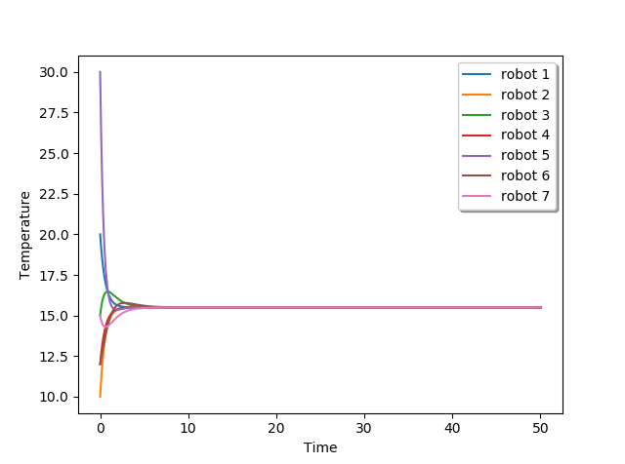

**Fig 1** Graph a for figure 1

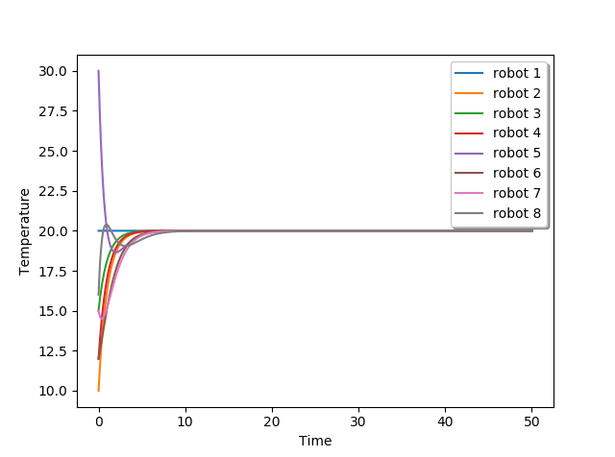

**Fig 2.** Graph b for figure 1

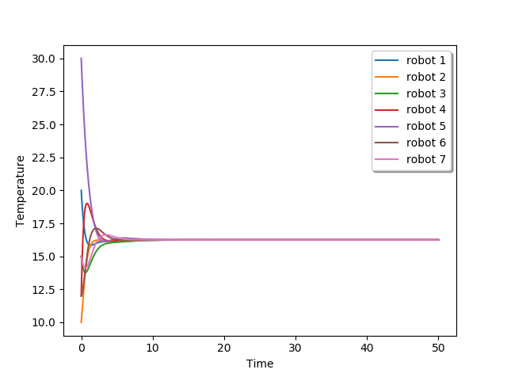

**Fig 3.** Graph d for figure 1

**Exercise 2**

**1)**

$\dot{x} = -x + y$

$$\dot{y} = -x- y$$

To find the fixed point $\dot{x} = \dot{y} = 0$

So we get, $x = y$ and $x = -y$

So the only fixed point we get to satisfy the above condition is $x = 0$ and $y = 0$.

**2)**

**a)** Yes, $V_{1}(x, y) = \frac{1}{2} x^{2}$ + $y^{2}$ is a Lyapunov function. Below shows the proof.

Given dynamical system,

$$\dot{x} = -x + y$$

$$\dot{y} =-x – y$$

$V_{1}(x, y) = \frac{1}{2} x^{2}$ + $y^{2}$

$\frac{dV}{dt} = x \dot{x}$ + $2y\dot{y}$

$=x\left(-x+y\right)+2y\left(-x-y\right)$

= ${-x}^{2} + xy - 2xy -2y^{2}$

$= {-x}^{2} - y^{2}-xy$

$= \frac{{-x}^{2}}{2} + \frac{{-x}^{2}}{2} {-y}^{2}-xy-\frac{{3y}^{2}}{2}$

$=\frac{{-x}^{2}}{2} -\frac{{3y}^{2}}{2} - {\left(\frac{x}{\sqrt{2}} + \frac{y}{\sqrt{2}}\right)}^{2}$

So from the above equation we can see that $\dot{V} < 0$ as for any values of x and y the function is negative. Since the system admits Lyapunov function it is asymptotically stable.

**b)**

$$V_{2}\left(x,y\right)=-x^{2}+100y^{2}$$

After finding the derivative of the we get $\dot{V}=2x^{2}+198xy+200y^{2}$. So since putting any values of the x we get positive $\dot{V}$ it does not satisfy $\dot{V} < 0$. Hence its not Lyapunov function.

**c) $$V_{2}\left(x,y\right)={\left(x-\frac{1}{2}y\right)}^{2}+\frac{7}{4}y^{2}$$**

$\frac{dV}{dt}=2\left(x-\frac{1}{2}y\right)\left(\dot{x}-\frac{1}{2}\dot{y}\right)$ + $\frac{7}{4} 2 y \dot{y}$

$=-2x^{2}+2xy+x^{2}+xy+xy-y^{2}-\frac{1}{2}xy-\frac{1}{2}y^{2}-\frac{7}{2}xy-\frac{7}{2}y^{2}$

$=-x^{2}+4xy-\frac{1}{2}xy-\frac{7}{2}xy-y^{2}-\frac{1}{2}y^{2}-\frac{7}{2}y^{2}$

$=-x^{2}-\frac{10}{2}y^{2}$

Since $\dot{V} < 0$, it’s a Lyapunov function.

**Exercise 4**

**1)** Yes, for each graph in figure 2 the consensus protocol will converge because each graph is rooted-out branching.

**2)** Yes, the system with switching graph will converge because since each graph is rooted-out branching , superimposing each other or union of all graph still gives rooted out branching. Therefore in figure 1 switching graphs will converge.

**3)** The code is in Ex4.3.py file.

**4)** Below shows the behavior for graph switching every 2sec and 0.1sec respectively.

Using initial condition as x_0 = [9, 96, 83, 78, 46, 73, 64] . The graph below shows convergence for

Switch time 0.1 and 2 seconds and both the graph converge at same point because the graphs are balanced and rooted- out.

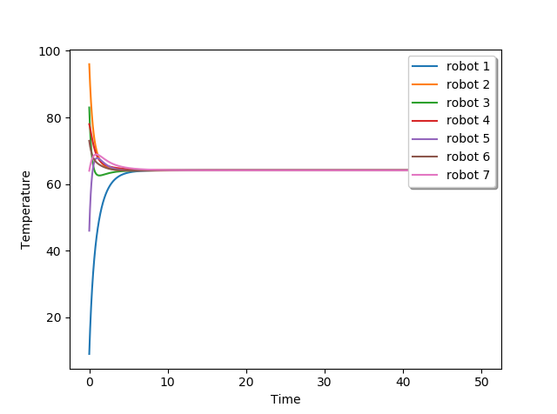

**Fig 4** Graph switching every 0.1 sec

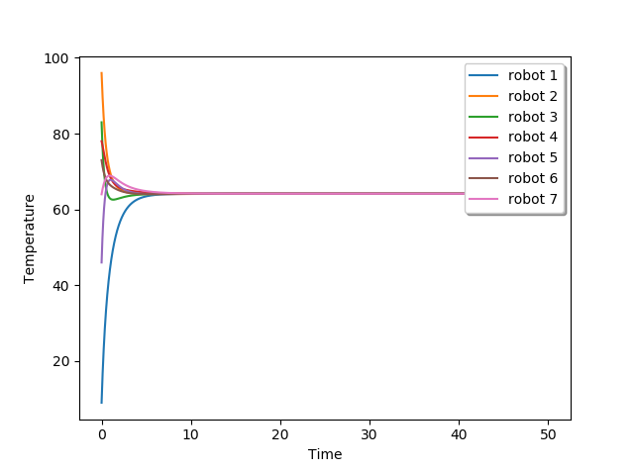

**Fig 5** Graph switching every 2 s

**Exercise 5**

**1)** No, the consensus protocol will not converge for any graph because there is no rooted out branching.

**2)** Yes, Because superimposing the graphs will give rooted out branching.

**3)** Graph below shows the behavior for each graph in figure 3 separately and with switching .

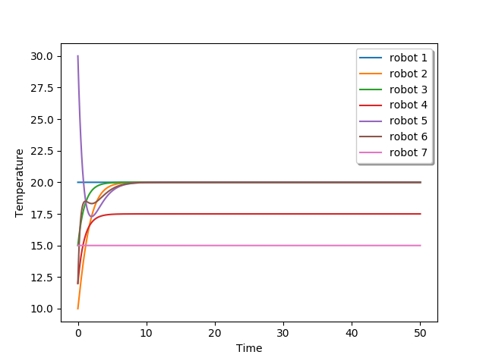

**Fig 6** Graph for figure 3a

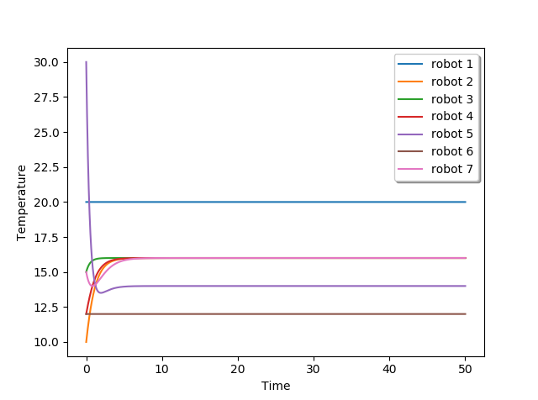

**Fig 7** Graph for figure 3b

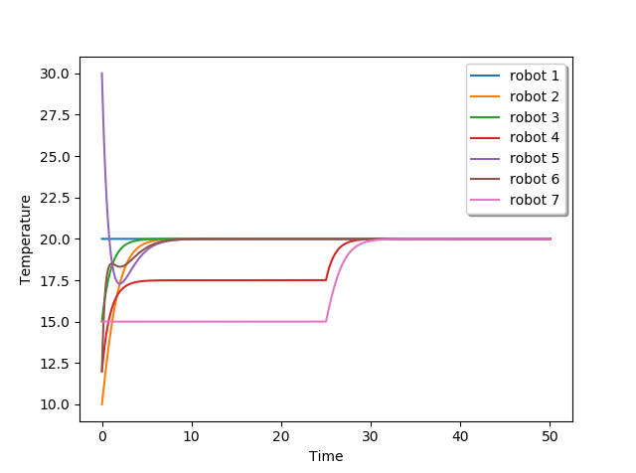

**Fig 8** Switch time 0.5 (figure 3)

**4)** Below are the switching graph every 0.1 , 0.3 and 2 seconds respectively for figure 3.

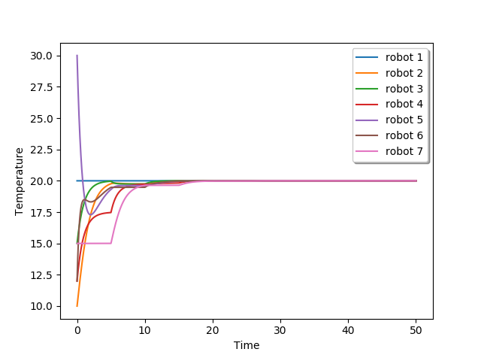

**Fig 9** Switching for graph 3 at 0.1 sec

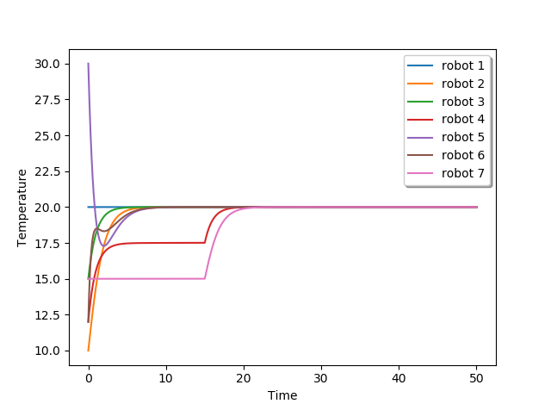

**Fig 10** Switching for graph 3 at 0.3 sec



**Fig 11** Switching for graph 3 at 2 sec

**Exercise 5 (Q5) – Figure 4**

**1)** No, the consensus protocol will not converge as there is not rooted out branching in any graph for figure 4.

**2)** Yes, Because superimposing the graphs will give rooted out branching.

**3)** Consensus protocol for each graph in figure 4 separately and with switching happening every 0.5 sec.

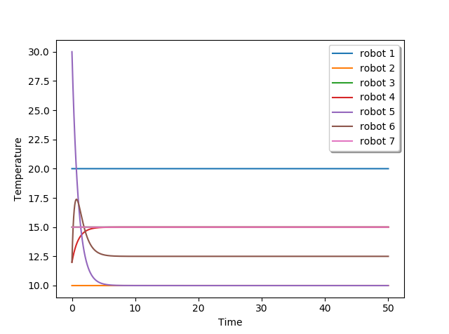

**Fig 12** Graph for figure 4a

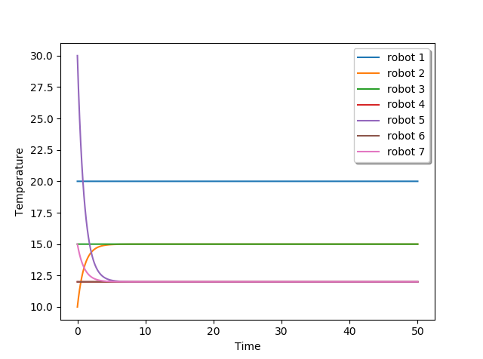

**Fig 13** Graph for figure 4b

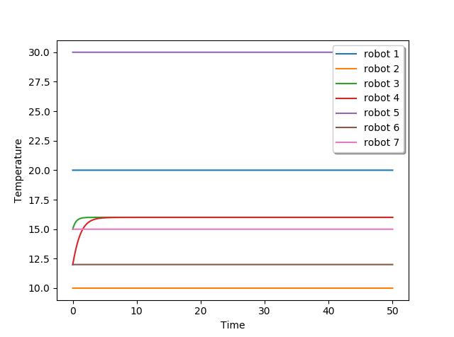

**Fig 14** Graph for figure 4c

**4)** Below are the graph for figure 4 for switch time 0.1, 0.3 and 2 seconds respectively.

The graph does not converge as shown below for T=50 sec.

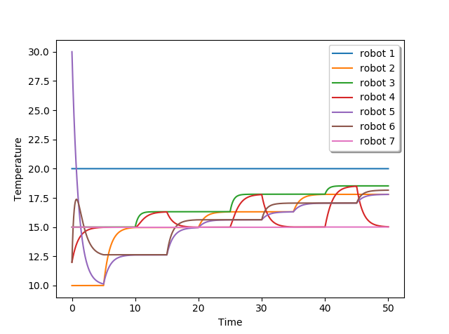

**Fig 15** Graph for figure 4 for switch time 0.1 sec

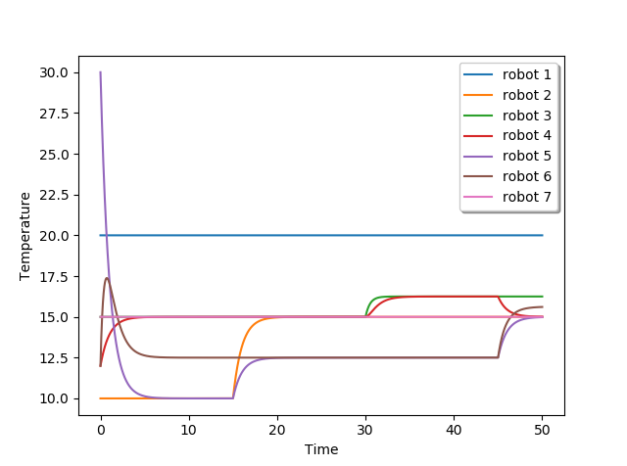

**Fig 16** Graph for figure 4 for switch time 0.3 sec



**Fig 17** Graph for figure 4 for switch time 2 sec